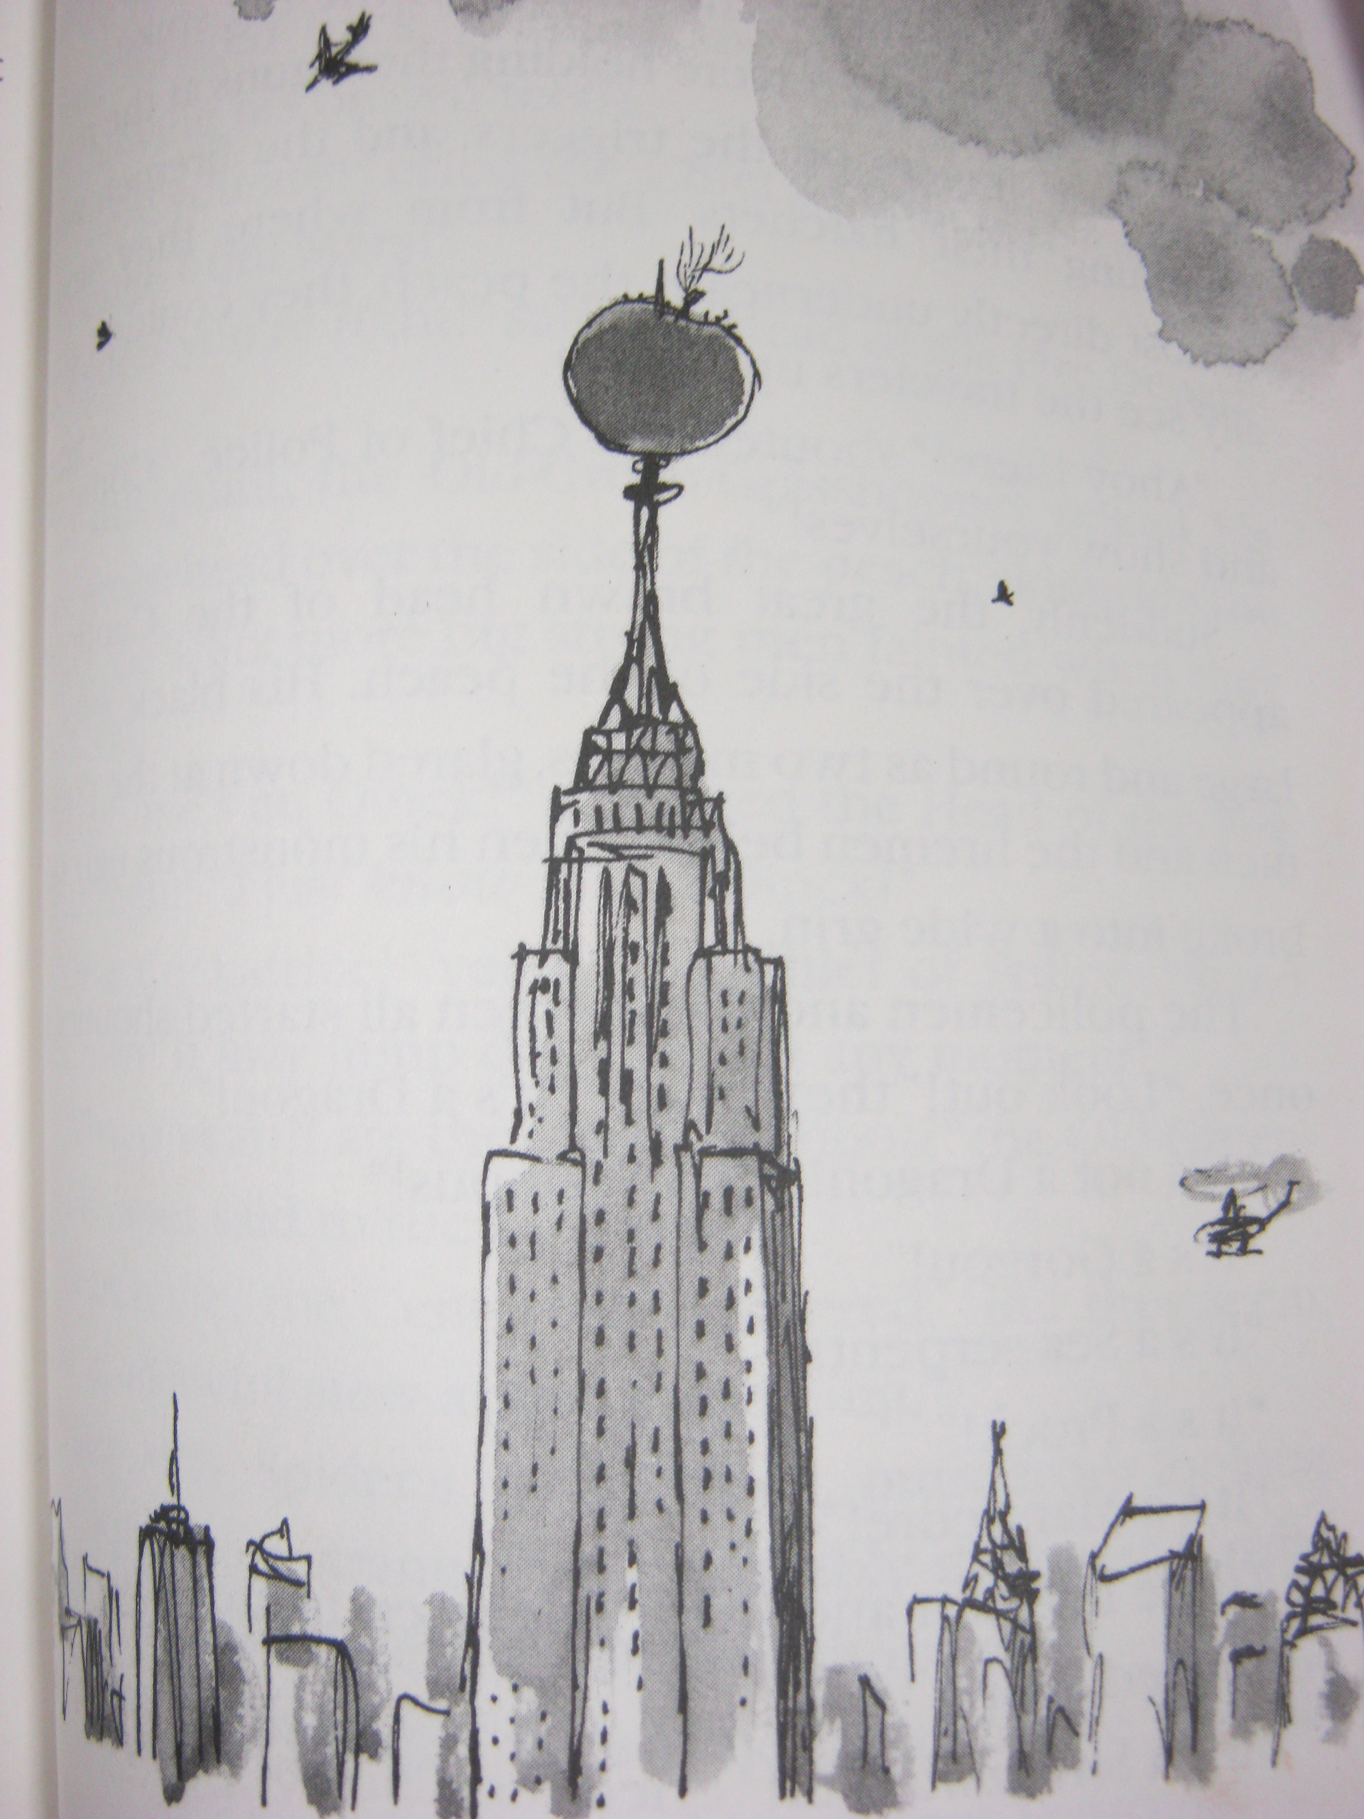
James and the Giant Peach
by Roald Dahl

James and his friends land on the Empire State Building! The Empire State Building is a very famous skyscraper in New York. Think about other famous skyscrapers or buildings in our Nation. Which one would you like to know more about?
Choose two that might interest you. You will be finding out more about it, and with a group. You will also work on a model to represent that building and to share the facts you learned.
My choices are ________________________________________________________________________________________________________________________________________________________________________________________________________Because
________________________________________________________________________________________________________________________

